Blimpscreen Summer Special!

Screen
1 Ea Widescreen Format 11 x 20 ft Blimpscreen Frame (Overall 24ft wide x 22ft High)
1 Ea 11 x 20 ft Perforated screen
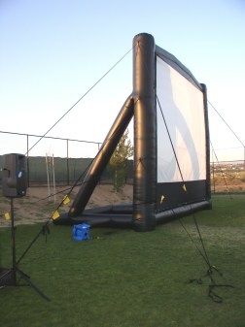
12 Ea High tension 1” webbing tethers (Not rope) with safety flags
6 Ea Pcs 18” steel stakes
1 Ea 4 Lb mallet
1 Ea 1.5 H.P. high pressure blower
1 Ea Repair Kit
1 Ea Bags for frame and screen surface

Video
1 Ea Sanyo or Eiki LCD Video Projector – 4000 Lumen
1 Ea Pelican hard case for projector

Sound
2 Ea DB Technologies 500 watt powered speakers
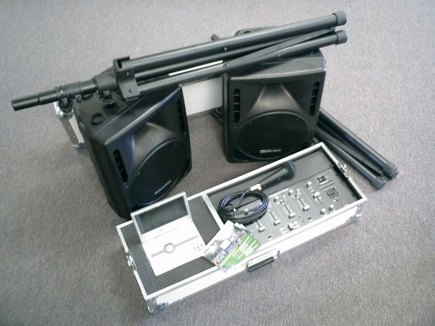
2 Ea Tripod speaker stands
2 Ea Soft speaker covers
1 Ea Microphone
2 Ea Speaker cables XLR 50 Ft
2 Ea Speaker cables XLR 25 Ft
1 Ea Mixer 19” rack mount, 6 Channel w/EQ
1 Ea DVD player 7” screen
1 Ea Custom sound/video console case
1 Ea Set up instructions

Package Price - $10,995.00
Delivery Immediate upon receipt of payment or City PO

WWW.Blimpscreen.com - (818) 557 0903 Email Mark@t2k.com

