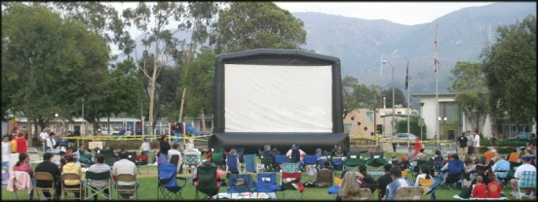

Blimp Screen Price List 01/01/07

Blimps Screens
w/Perforated Screen Surface, blower (1.5 HP),
tethers, bags, stakes, repair kit & mallet. All sizes are actual visible screen size.
16.5x30 ft BigBoyBlimp $9,695 Special Order – 2 weeks
18x24 XB (Xtra Beefy) $8,395 In Stock - Winter Special $7995
13.5 x 24 ft (HDTV) $8,395
15 ft x 20 ft $7,395 In Stock – Winter Special $6995
11.5 ft x 20 ft (HDTV) $7,395
11.25 ft x 15 ft $5,295
7.5 ft x 10 ft $4,295 In Stock
Baby Blimp (6x8 ft ) $2,795

Additional Items
Additional Screen Surface $695
Rear Blackout Drape $495
Hi Pressure Blower (1.5HP) $495
Road Case w/wheels $695
Work lights w/stand (2 sets) $149
Heavy Duty Steel Tent Pegs $12
Sledge mallet – 4 lb $25
Followspot – 1000 watt $959
Projector hard-shell Pelican case 1550 $195
LCD Projectors
PLC-XP51 - 4000 Lumen $4,995
PLC-XP55 - 4500 Lumen $7,295
LX 500 - 4000 Lumen $4,595
LX 400 – 3600 Lumen $3,795
PLC – 2000 Lumen (For 7x10 & 6x8) $1,995

Video Mixer $1,195
Sound System
DB Technologies OPERA Lyric
550 watt 15" 2way spkrs
2 Powered Speakers w/tripod stands and
mixer - incl 1 mic and audio cables $1,995
2 additional speakers on stands $1,700
BBB – FM Transmitter System $1,995
Speaker bags $59.95

Complete Movie in the Park Package
15x20 System
Pair of 550 watt powered DB Technologies
speakers on stands, audio cables,
microphone and audio mixer
Mixer Case and FREE 7” DVD player
Sanyo 4000 lumen LCD projector $13,995

Rental Packages
15 x 20 Screen only $750
Shipping cost (To You) $150 (approx)

Full package with sound, video, DJ,
Delivery, install etc
(Travel additional) $2,500

www. Blimpscreen.com - (818) 557 0903 – Email Mark@t2k.com

