Blimpscreen Rentals

Screen Only Rental

The 15x20 Blimpscreen is available for rental and can be shipped anywhere in the USA. Our rental rate is for 1-2 days of usage and allows for a total of 6 days shipping time. We do not rent out the sound system or video projector, as you should be able to find these items locally and avoid the shipping cost. The NEW 7x10 screen is now available for rental at $495 per week.

The screen will ship in two boxes containing the frame and screen in one and the blower and accessories in the other. Shipping charge will be approximately $150 each way in the U.S.

Rental Rates 15x20 7x10

1 Week $750.00 $495 per week
2 Weeks $500.00
4 Weeks $450.00

Your first week rental will be deducted from the cost of the screen if you wish to keep the unit. If you are seriously considering the purchase, please let us know before we ship so we can pre-arrange a purchase price for the unit we send to you.

Sound and Video

Sound System – 2 powered speakers with stands, microphone, mixer etc $250
Additional Speakers (Pair) $200
Video Projector – 4500 Lumen $375
Video Projector – 2000 Lumen $195

Sound and video rentals are for local pick-up only in the Los Angeles area and are weekend rates.

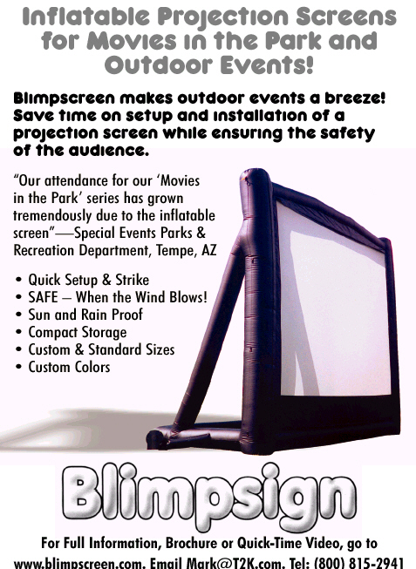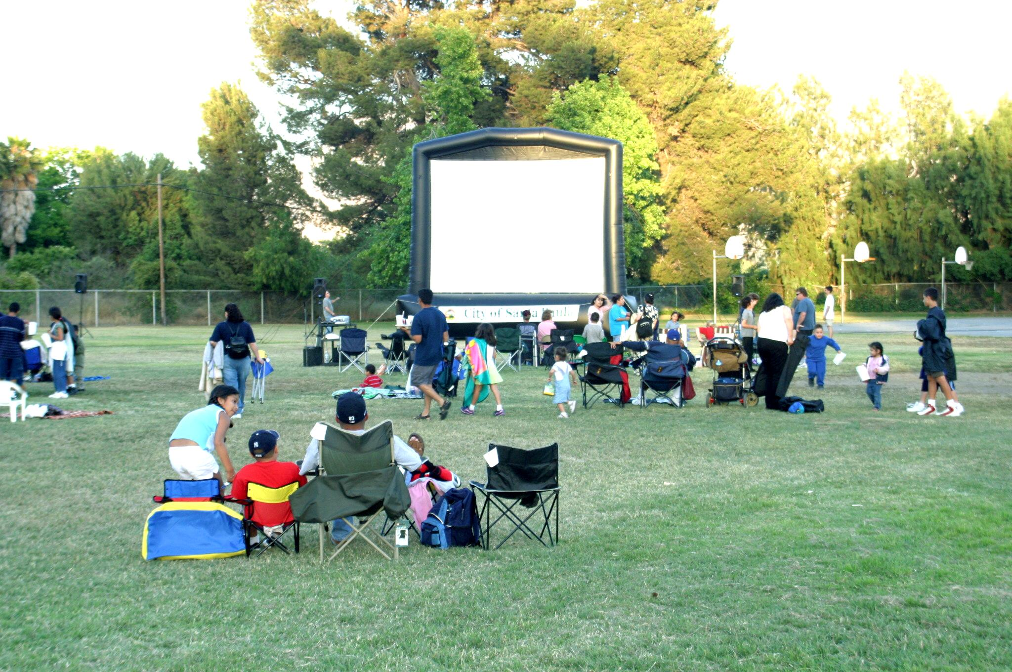

Straight rental or complete Movie in the Park Production

Complete Show Rental
We can also provide a complete Movie in the Park production, including the screen, projector, sound system and complete set up, operation and strike.
The cost for the service locally is $2500.00 (S.California) plus the cost of the movie rental. We offer discounts for multiple shows during a season. To select a movie go to www.swank.com or http://www.criterionpicusa.com . When you arrange the movie through these companies all of the licensing fees are included for legal exhibition and usually will not exceed $300.00 for a latest run movie. We also have operators all around the U.S.

Blimpscreen (818) 557 0903 www.blimpscreen.com

