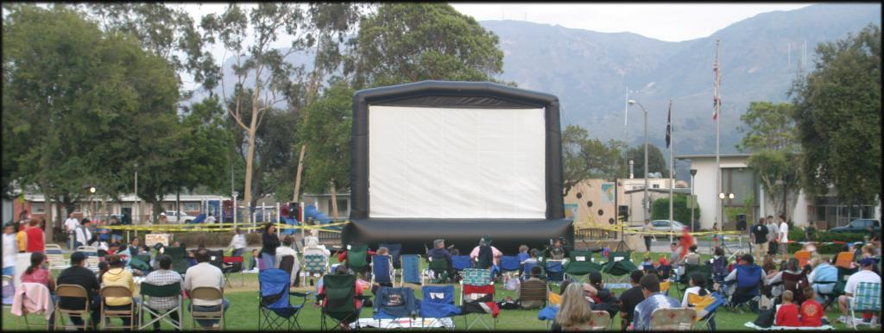

Movie In The Park Package

The ideal family activity for a summer evening. Grab the cooler and the lawn chairs and head down to the park for a movie!

Becoming more and more popular nationwide Parks & Recs. and individuals are putting on a movie in a park near you. We can provide all the bits that need to make it happen – you bring the people!

Package Includes:
18x24 ft Inflatable Blimpscreen
Sound System for up to 1000 people
High brightness video projector
DVD Player and microphone for announcements
Music videos for pre-show entertainment

+The Movie
Main feature movie – fully licensed from $250 or you can provide the movie yourself from any other legal source.

Package Price includes complete delivery, set up, operator, and tear down.
$2,500.00
We can provide operators in many parts of the country.

Complete packages also available for sale.

Visit our site at www.blimsign.com
Or call (818) 557 0903
215 W Palm Ave., Burbank, Ca 91502

