MMovie in the Park – Blimpscreen Package

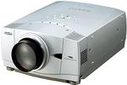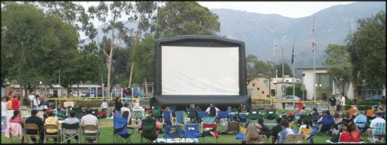

Sanyo PLC-XP45
3500 Lumen LCD projector - $5695
Sanyo PLC-XP46
4100 Lumen LCD projector - $5995
Sanyo PLC-XP55
4500 Lumen LCD projector - $7295

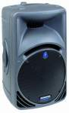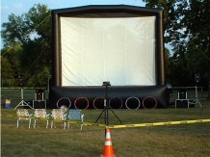

DB Technologies 550 watt
Lyric 415
Powered Speakers w/tripod stands
Pair - $1500

Sanyo PLC-XP46 Features:
- 4100 ANSI Lumens (typical)
- True XGA (1024 x 768) resolution, compressed UXGA resolution
- 800:1 Contrast Ratio
- Power Lens Shift (Up/Down)
- Power Zoom/Power Focus
- Eco mode lamp setting extends lamp life with minimal Lumens reduction
- Digital Keystone Correction
- Digital Visual Interface (DVI)
- Whisper Quiet Fan (37 dBA)
- 3-D Digital Progressive Scan v3-D Digital Noise Reduction
- A Variety of Lens Options Available PLC-XP46 ships with a standard lens, PLC-XP46L ships with no lens

Complete Movie in the Park Package
18x24ft Blimpscreen w/2 blower units and tie downs
Pair of powered DB Technologies speakers on stands (add $750 per additional spkr w/stand)
Sanyo 3500 lumen LCD projector
$14,385 (3500 Lumen Sanyo)
$15,490 (4100 Lumen Sanyo)
$16,990 (5000 Lumen Sanyo)

www.Blimpsign.com Phone (818) 557 0903 Email Mark@T2K.com

